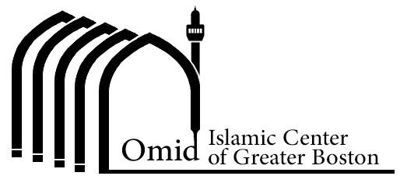
320 Boston Post Road, Weston, MA

www.omidcenter.com Telegram:@OCofGB Email: omid.center@yahoo.com
WhatsApp Group Invite: :https://chat.whatsapp.com/KJaNxZYr7qw3Dv9tm2r3Th
Ramadan Corner: https://omidcenter.com/ramadan-corner/

Weekly Saturday Program: May 11, 2019 at 6:30 PM

Location: Omid Center, 320 Boston Post Road, Weston, MA
Program:
6:30-7:00 Quran Recitation
7:00-7:45 Lecture by Dr. Soheyla Emami (in Farsi)
عنوان:اثرات روزه بر جسم ، روح و روان
Title: "The Effects of Fasting on the Body, Soul, and Mind"
7:45-7:55 Question and Answer
7:55-8:15 Dua Iftitah
8:15-8:35 Prayer
8:35-9:30 Iftari/Dinner (Donated)
Potluck Dessert
9:30-10:00 Cleaning
10:00 End of Program

